TITLE: Airline Data Analytics for Avaition Industry

Team ID: PNT2022TMID15316

Upload the dataset to Cog Analytics, explore and visualize the dataset

1.Uploading Dataset to IBM Cognos Analytics:

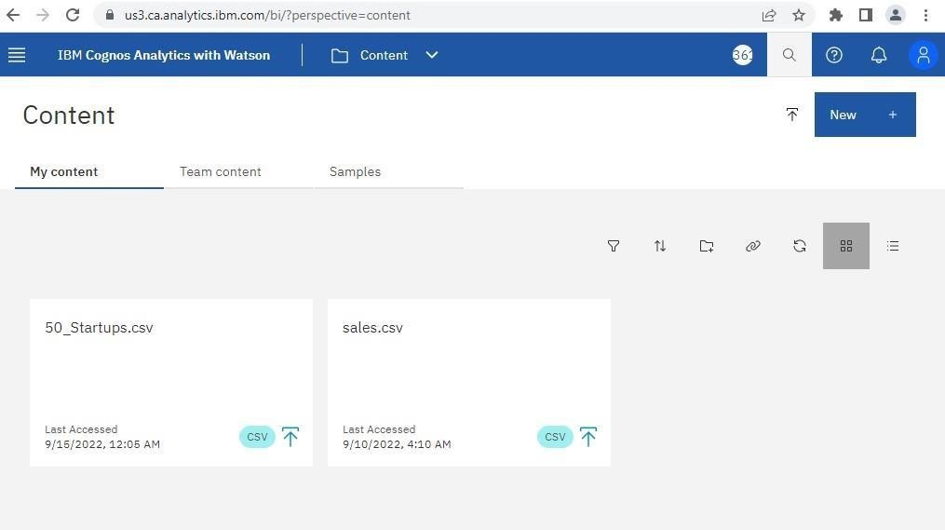

2.Data Exploration:

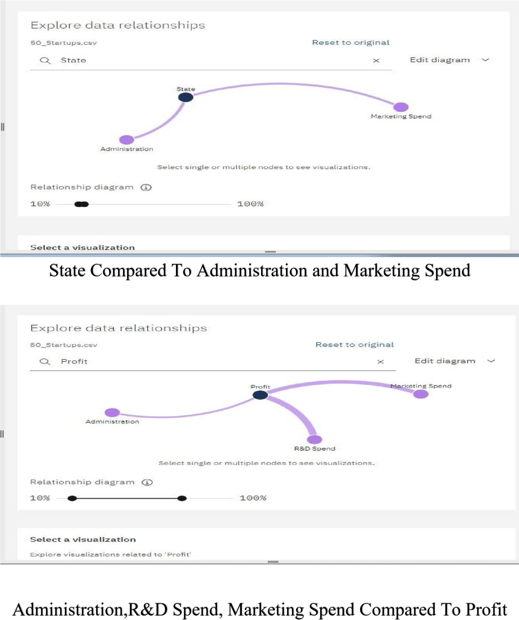

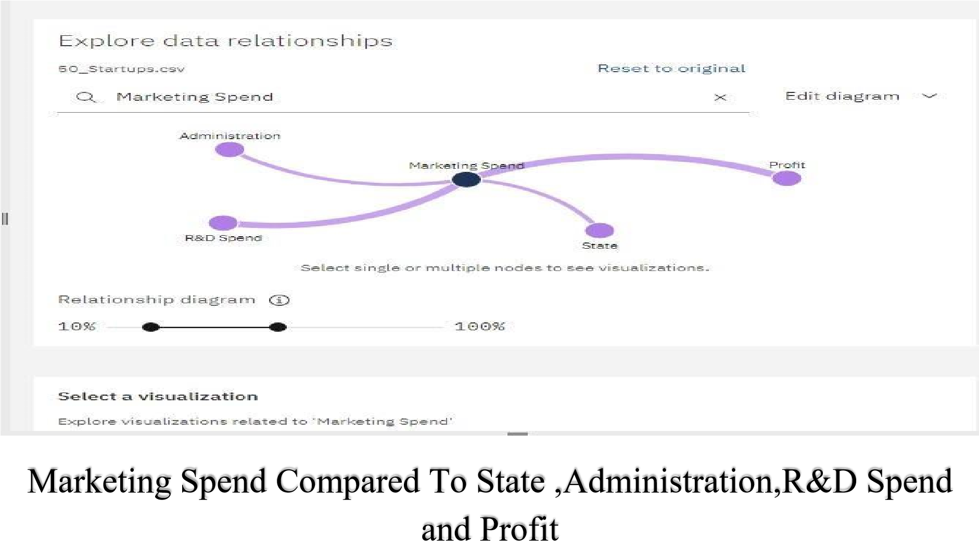

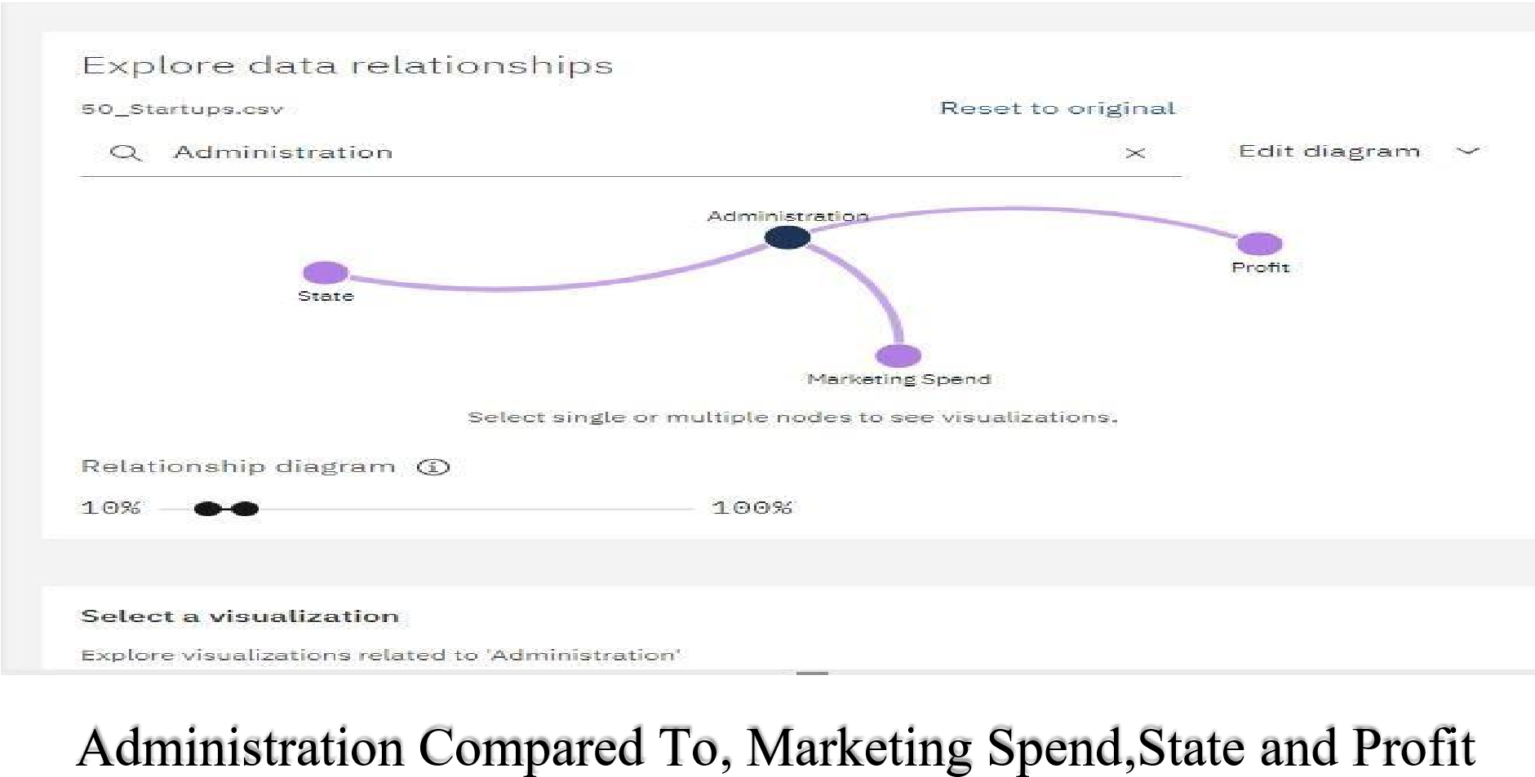

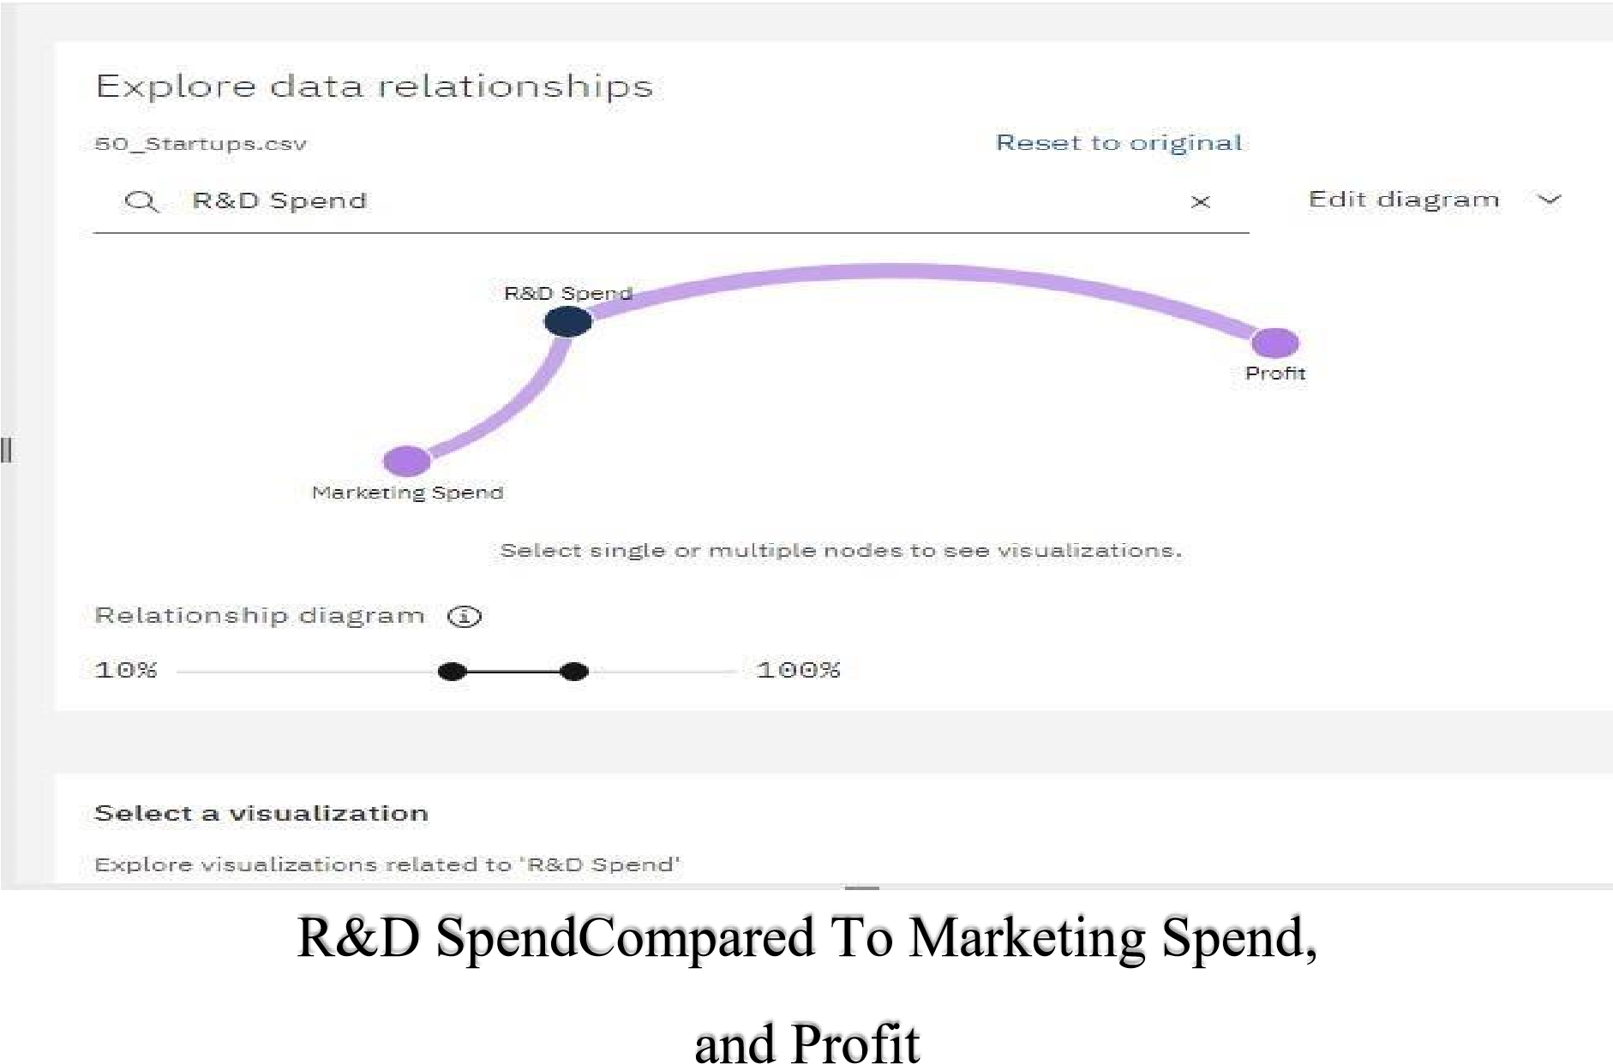

3.Data Visualization:

Bar chart Representation:



Bar chart for Profit to R&D Spend

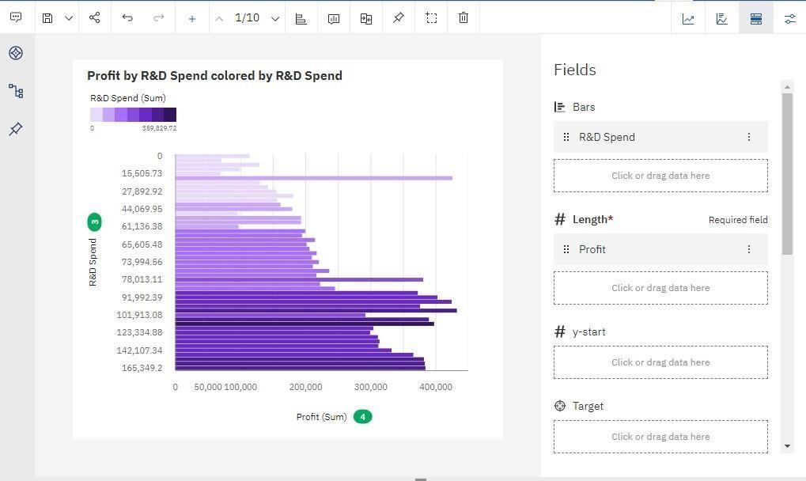

Profit Compared to State

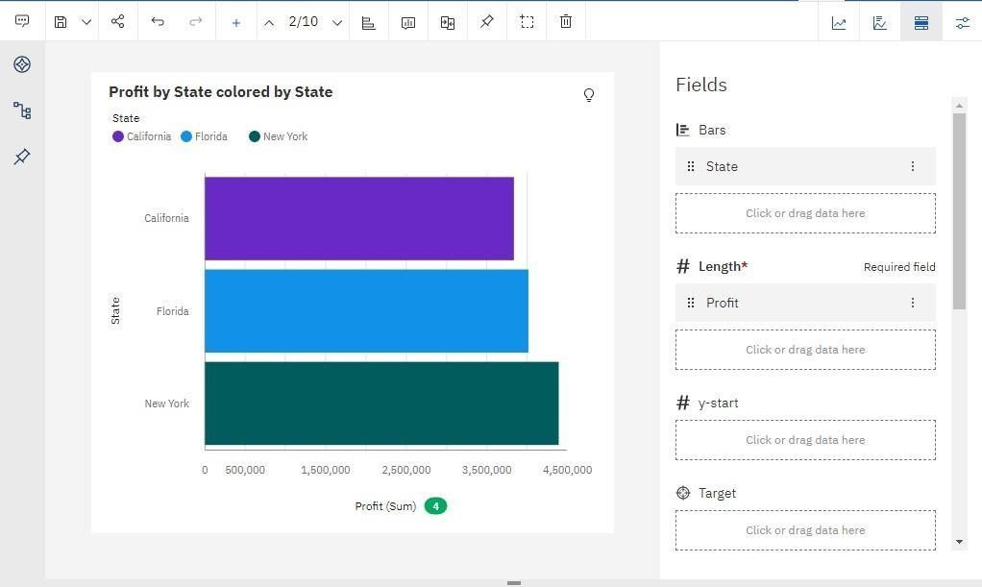

Profit Compared to Administration

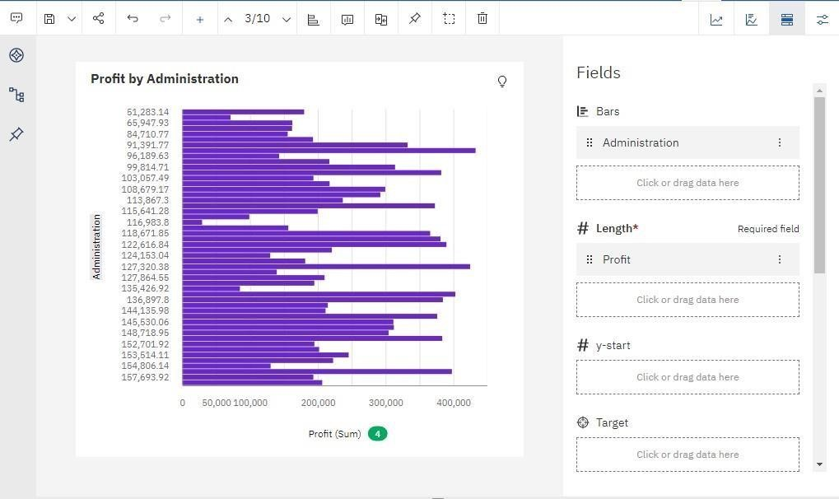

Profit Compared to Marketing Spend

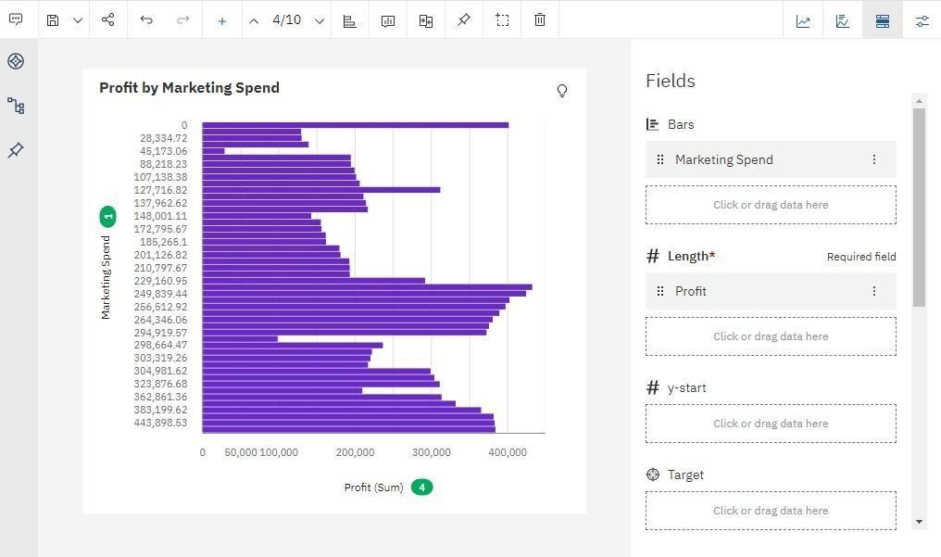

Profit Compared to R&D Spend,Administration,Marketing Spend and

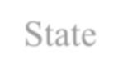

S



tate

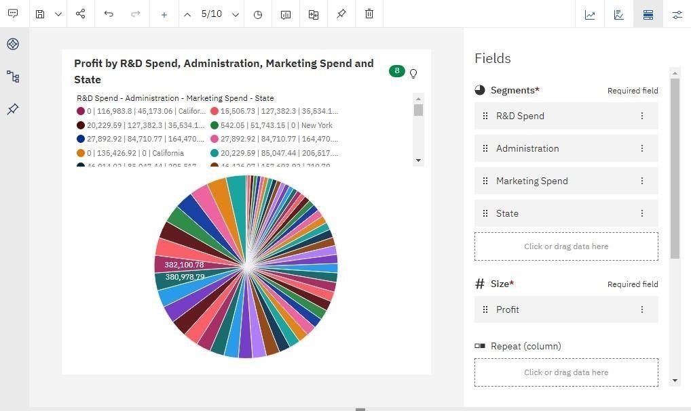

Pie Chart Representation:

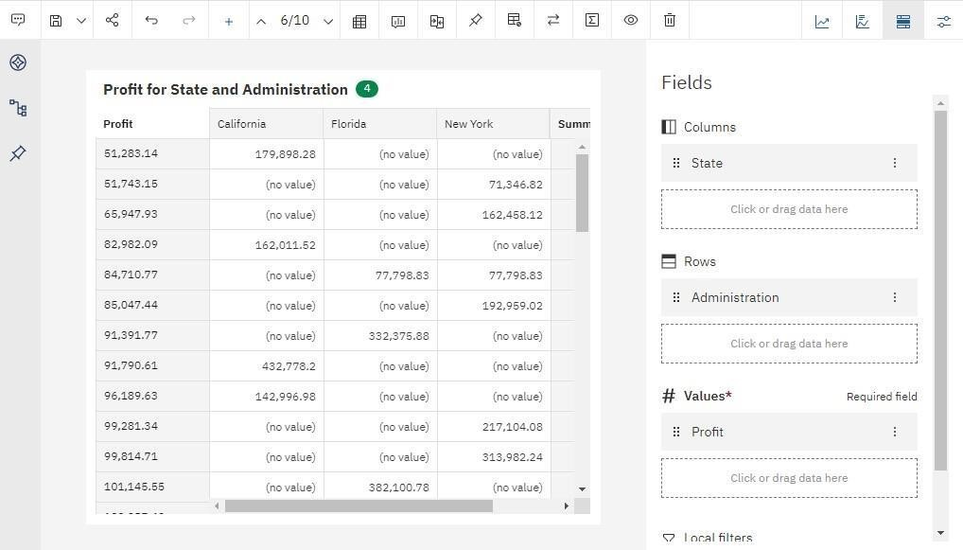

Profit For State and Administration

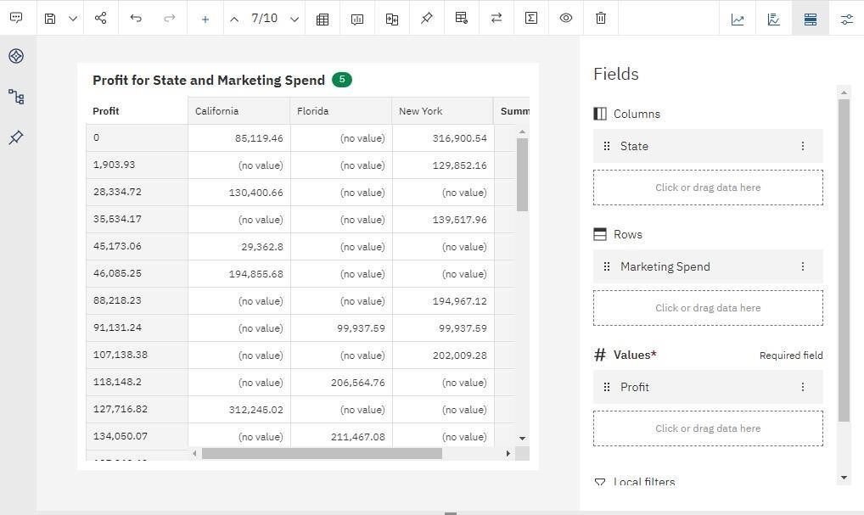

Profit For State and Marketing



Profit For State and Marketing Spend

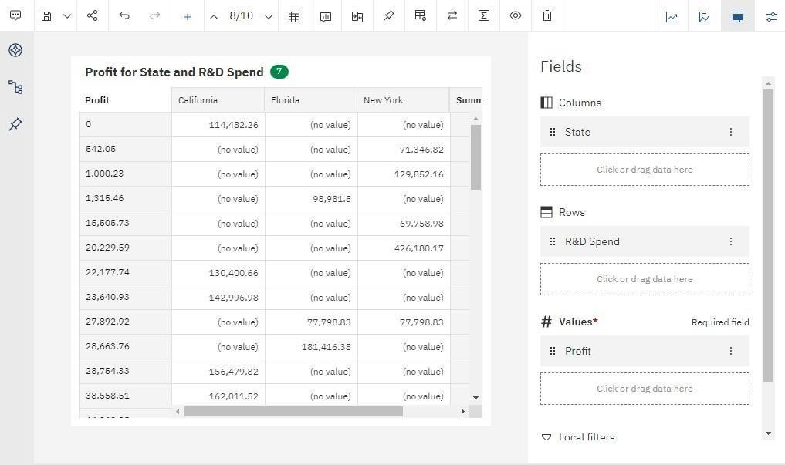

Profit For State and R&D Spend

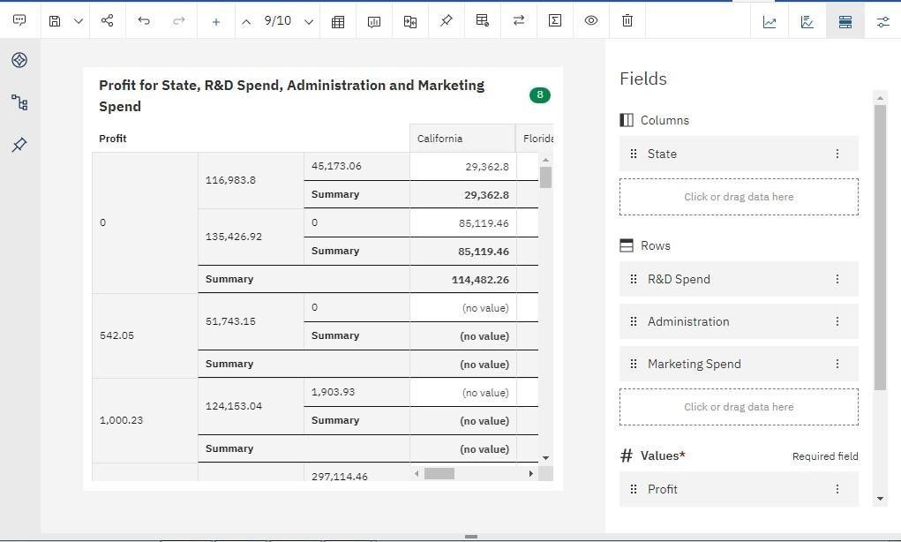

Profit For State,R&D Spend,Administration and Marketing Spend